Nama: M Alvin Khoirul Rizky

NIM:2200018141

Kelas C

Matkul: Dasar Sistem Komputer

Judul Aplikasi: Program Biling Warnet

Link Github: https://github.com/AlvinKhoirul/program-biling-warnet.git

Link youtube: [https://www.youtube.com/watch?v=BXK4fKznjHQ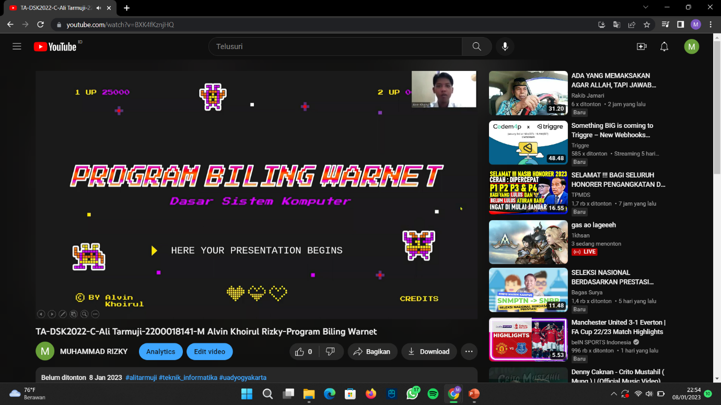](https://www.youtube.com/watch?v=BXK4fKznjHQ#)

